**Device Widths for Responsive Design Planning**

**3 Layouts**

Layout 1: iPhone (320/640px)

Layout 2: iPad (768/1536px)

Layout 3: Desktop full width (960px)

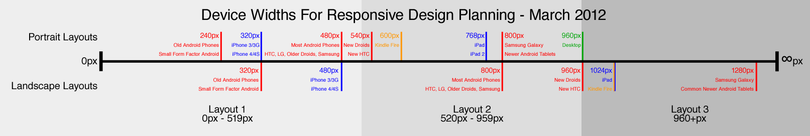

**4 Layouts**

Layout 1: iPhone (320/640px)

Layout 2: Kindle Fire at 600px

Layout 3: iPad (768/1536px)

Layout 4: Desktop full width (960px)

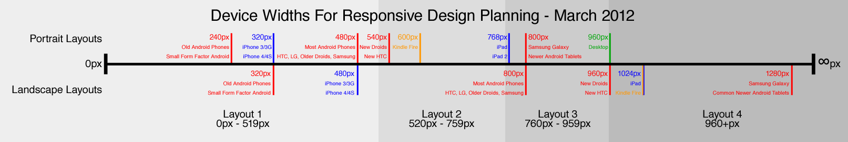

**6 Layouts**

Layout 1: 240px devices

Layout 2: iPhone (320/640px)

Layout 3: This design can probably

Layout 4: A design just for Kindle Fire (600px) in portrait.

Layout 5: iPad (768/1536px)

Layout 6: Desktop full width (960px)

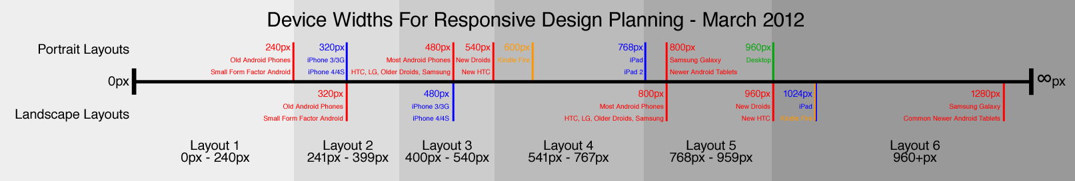

**Media Queries**

@media screen and (max-width: 600px) {} < 600px

@media screen and (min-width: 900px) {} >900px

@media screen and (min-width: 600px) and (max-width: 900px) {} 600-900px;

@media screen and (max-device-width: 480px) {} 480 device trigger

**For iPhone 4**<link rel="stylesheet" media="only screen and (-webkit-min-device-pixel-ratio: 2)" type="text/css" href="iphone4.css" />

**For iPad** <link rel="stylesheet" media="all and (orientation:portrait)" href="portrait.css">

<link rel="stylesheet" media="all and (orientation:landscape[横向])" href="landscape.css">

Android

/*240px的宽度*/

<link rel="stylesheet" media="only screen and (max-device-width:240px)" href="android240.css" type="text/css" />

/*360px的宽度*/

<link rel="stylesheet" media="only screen and (min-device-width:241px) and (max-device-width:360px)" href="android360.css" type="text/css" />

/*480px的宽度*/

<link rel="stylesheet" media="only screen and (min-device-width:361px) and (max-device-width:480px)" href="android480.css" type="text/css" />

1、link方法引入

<link rel="stylesheet" type="text/css" href="../css/print.css" media="print" />

2、xml方式引入

<?xml-stylesheet rel="stylesheet" media="screen" href="css/style.css" ？>

3、@import方式引入

@import url("css/reset.css") screen;